**Appendix**

1. **Upsampling and downsampling**

**a)**

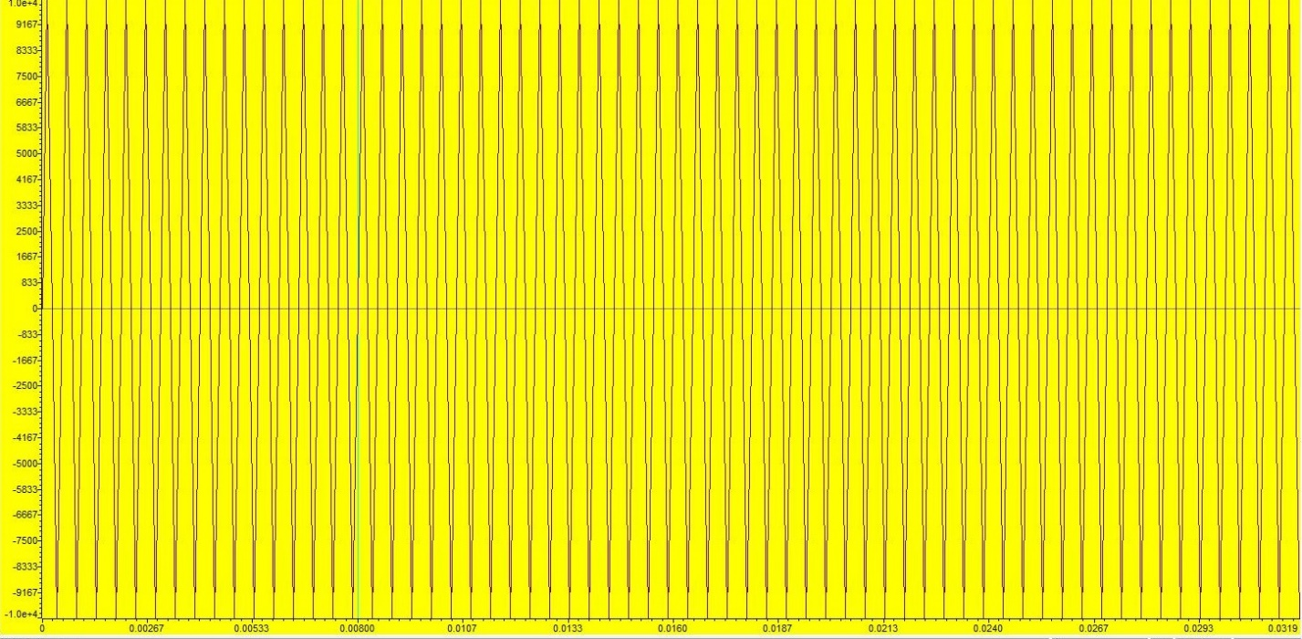

**Time domain plot Fs=8 KHz**

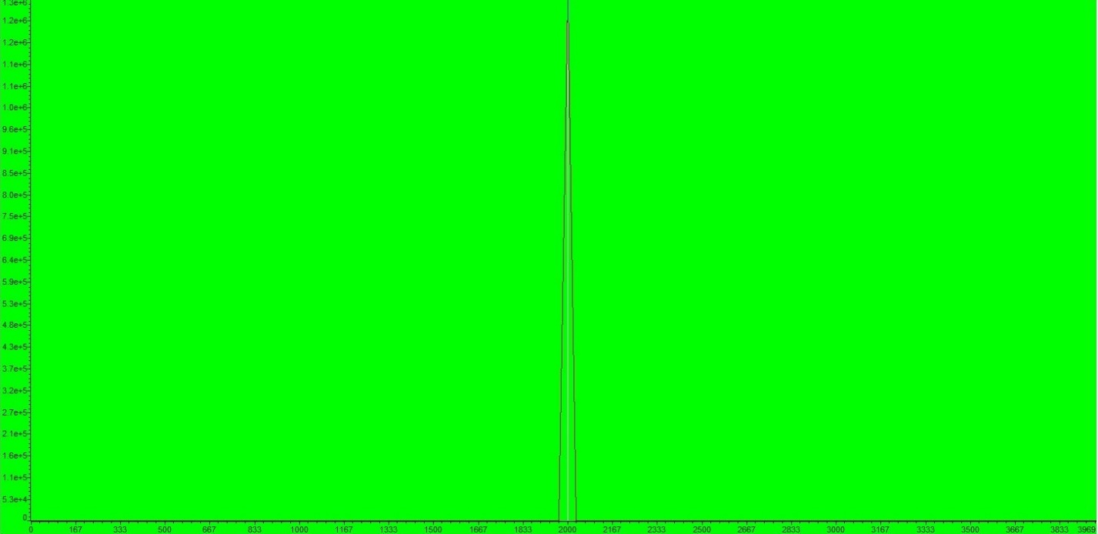

**Frequency domain plot Fs=8 KHz**

**b)**



**Time domain plot Fs=8 KHz**

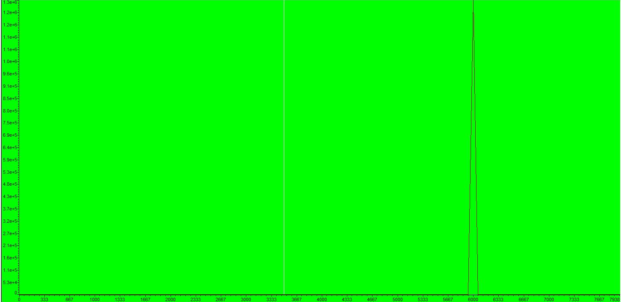

**Frequency domain plot Fs=8 KHz**

**c)**

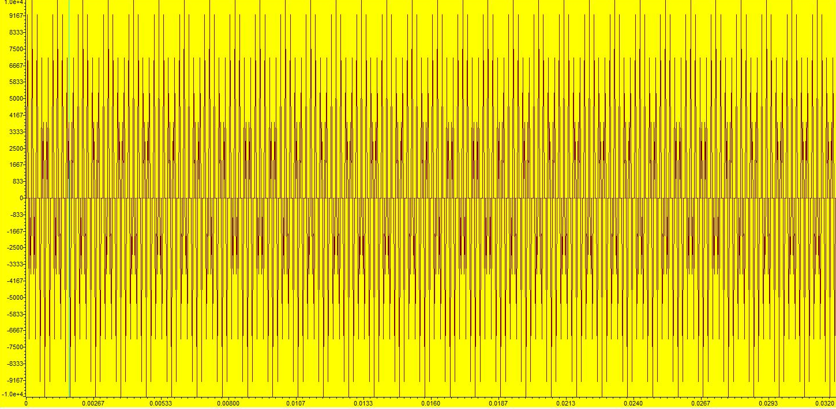

**Time domain plot Fs=32 KHz**

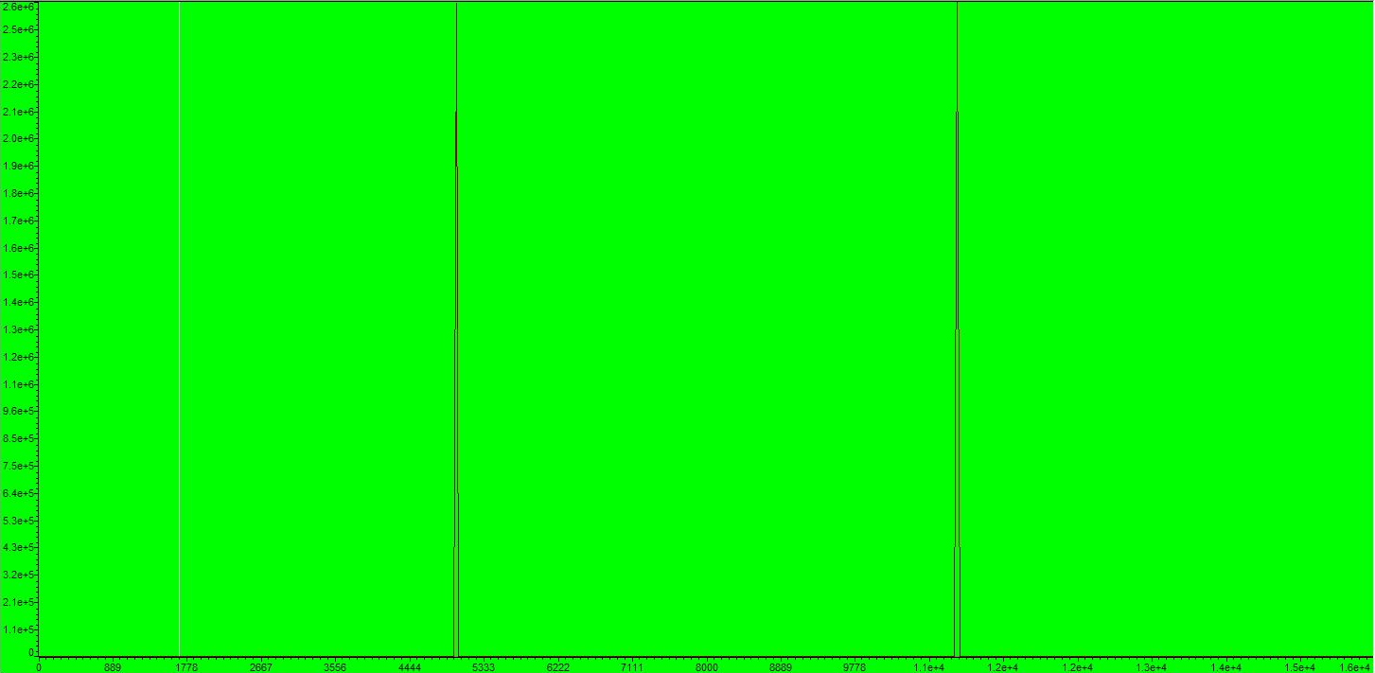

**Frequency domain plot Fs=32 KHz**

**d)**

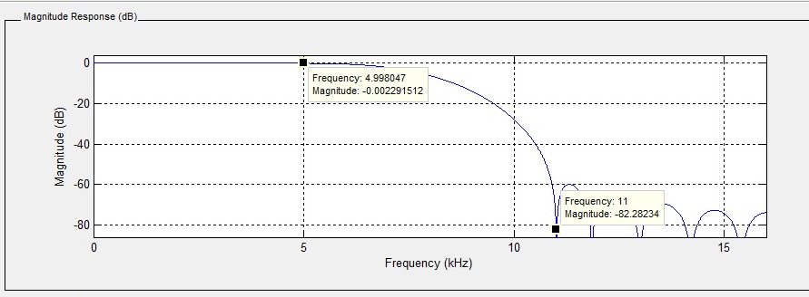

**Magnitude response of the LPF**

1. **Analysis Filter Bank and Synthesis Filter Bank Coefficients**



**Magnitude response**



**Impulse response**

1. **Non-efficient Implementation of Two-channel Filter Bank**



**Input (blue) and output (red) of the filter bank**

1. **Efficient Implementation of Two-channel Filter Bank**



**Input (blue) and output (red) of the filter bank**